
QUALITY ALERT

Customer: ChamClad Date: May 14, 2025
Die: 15748-15750 Color: ALL
Type of Complaint: ChamClad REJECTED

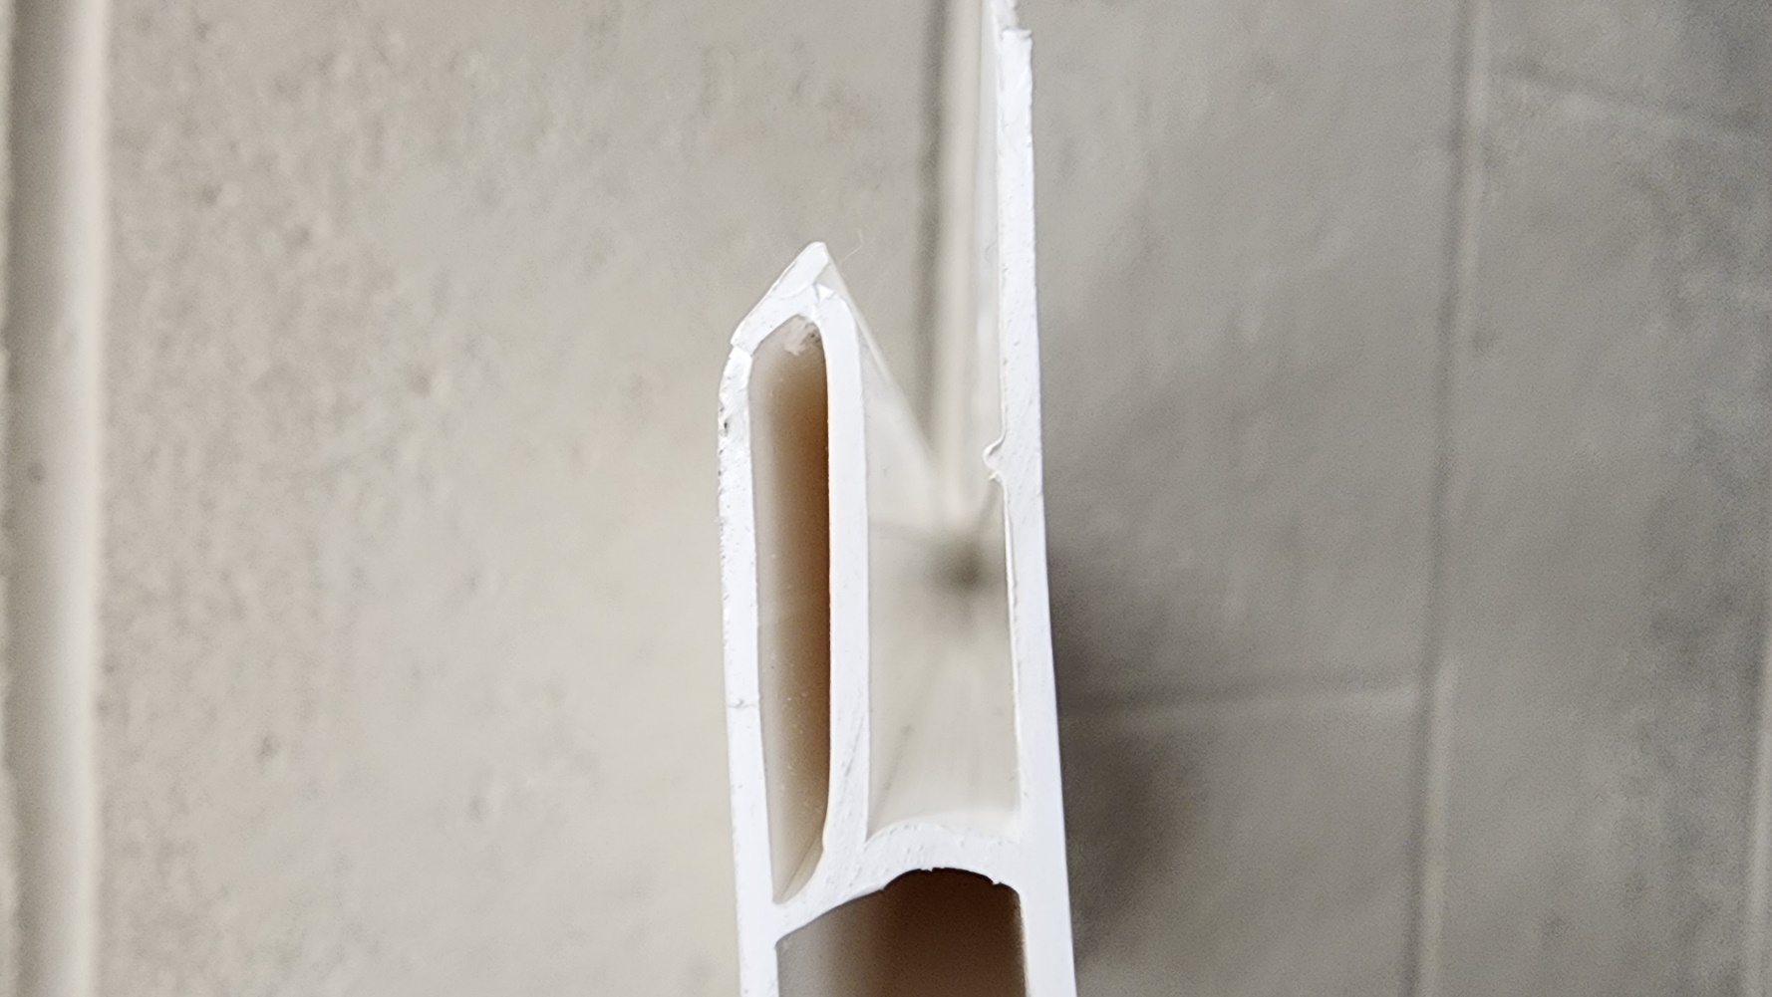
Q.A # 25-004 NCR: 081

Description: ChamClad REJECTED – Material was missing nip / out of shape.
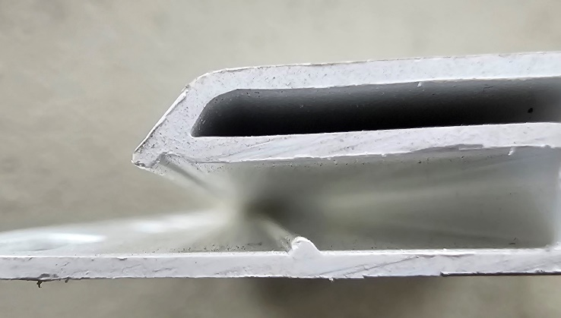

GOOD

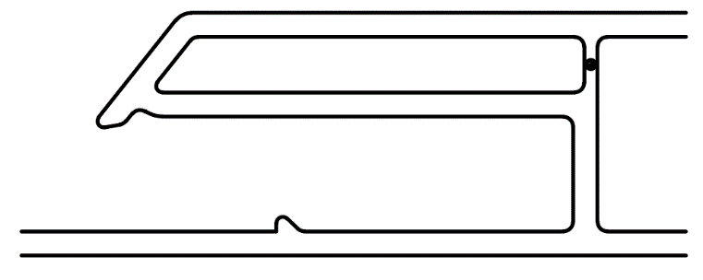
BAD

INSPECT MATERIAL TO ENSURE NIP IS NOT MISSING BEFORE PACKING

BY SIGNING BELOW, YOU ACKNOWLEDGE THE PROBLEM ABOVE AND AGREE TO MONITOR THIS ISSUE IN FUTURE PRODUCTION RUNS.
DAY SHIFT |  | AFTERNOON SHIFT |  | NIGHT SHIFT
NAME | SIGNATURE | NAME | SIGNATURE | NAME | SIGNATURE
F-006: Quality Alert | Eff.Date: 05/03/2025 | CC# 25-046 | Rev.0

